

Student name:

Pham Hoang Thai

BannerID:

001392862

Lecture:

Phan Minh Tam

Group member:

Nguyen Tran Le Thanh

Pham Hong Son

Pham Hoang Thai

Vo Tuan Kiet

Duong Van Hiep

Tran Le Duy Trong

2023-2024

Enterprise Web Software Development

INDIVIDUAL COMP1640

Table of Contents

1 Evaluation of Product and Process 2

1.1 Evaluation of Product 2

1.2 Evaluation of Scrum Process 7

2 Evaluation of team 9

2.1 Grading 9

2.2 Evaluation 10

3 Self – evaluation 12

3.1 Contribution 12

3.2 Experience gained 14

4 Material 15

Conclusion 16

# Evaluation of Product and Process

## Evaluation of Product

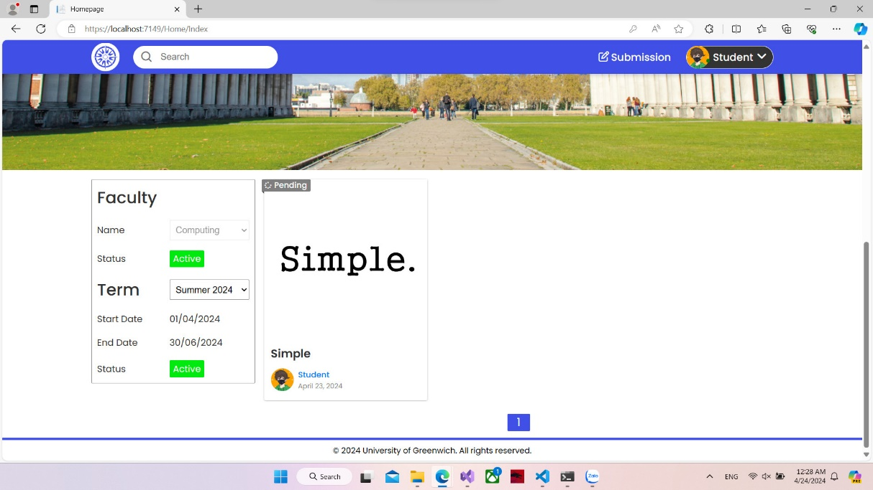

Home page

On the homepage's frontend, user submissions are prominently displayed in a way that is both intuitive and user-friendly. The layout is designed with harmony in mind, utilizing a cohesive color scheme and consistent typography that enhances the overall aesthetic appeal. Each function is strategically placed, following logical patterns that align with common user behaviors and expectations. This thoughtful arrangement ensures that users can navigate the platform with ease, intuitively understanding where to click to perform their desired actions. Overall, the homepage serves as a gateway, providing a straightforward, seamless experience that encourages user interaction and engagement.

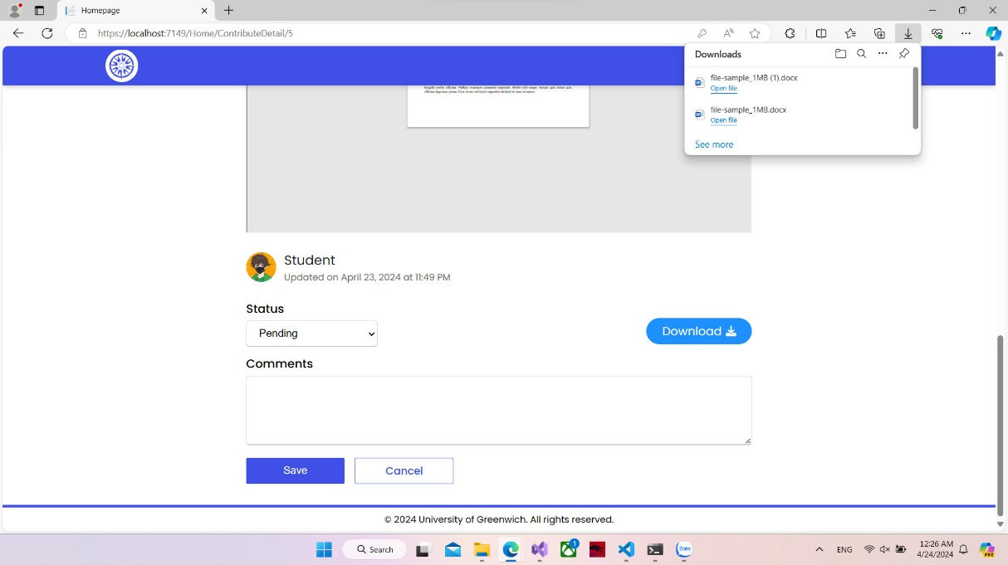

Download file

The interface exemplifies the user-friendly nature of the download functionality. Upon interacting with the download button, the application promptly springs into action, preparing the file to be downloaded. It’s a straightforward process that highlights the system’s efficiency: with just a single click, the file is processed and made ready for the user. This reflects the application’s commitment to providing a convenient and hassle-free user experience, where ease of access and simplicity are key priorities. The visibility and responsiveness of the download feature ensure that users feel empowered and capable, making file acquisition a seamless part of their digital interaction.

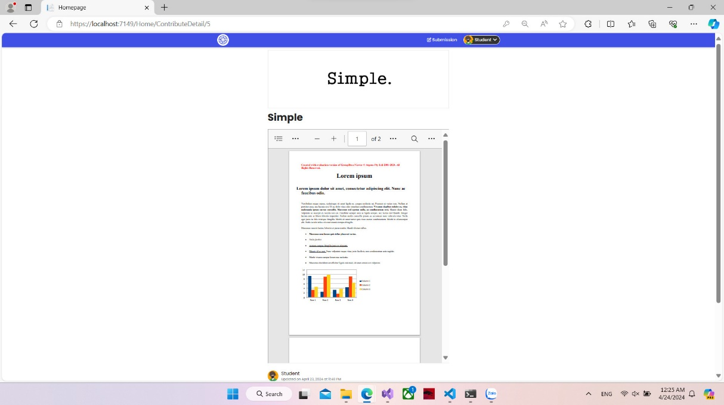

Submission detail

Displayed prominently on the screen are the various attributes of submissions, such as an image that typically represents the content, a title that succinctly encapsulates the essence of the submission, and a brief preview of the document. This preview allows users to get a quick glimpse of the document's content, creating an informative snapshot that can help them decide whether to engage further. Each element is designed to provide just the right amount of information, striking a balance between utility and simplicity, and contributing to an effective and streamlined user experience.

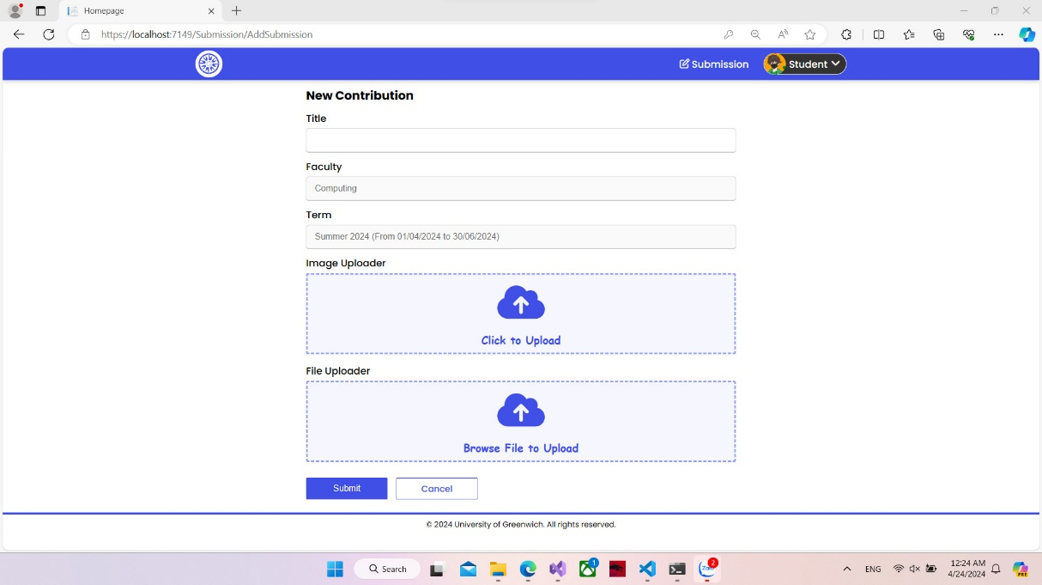

Upload new submission

The display in question details the front end for submitting a new entry. To successfully submit, it is imperative that users complete all required data fields. This ensures that each submission is accompanied by the necessary information, promoting a standardized format that facilitates organization and review. Clearly labeled fields guide the user through the submission process, from start to finish, making it easily navigable and user-friendly. This structured approach to data entry is key not only to maintaining the integrity of the data collected but also to creating a seamless experience for the user.

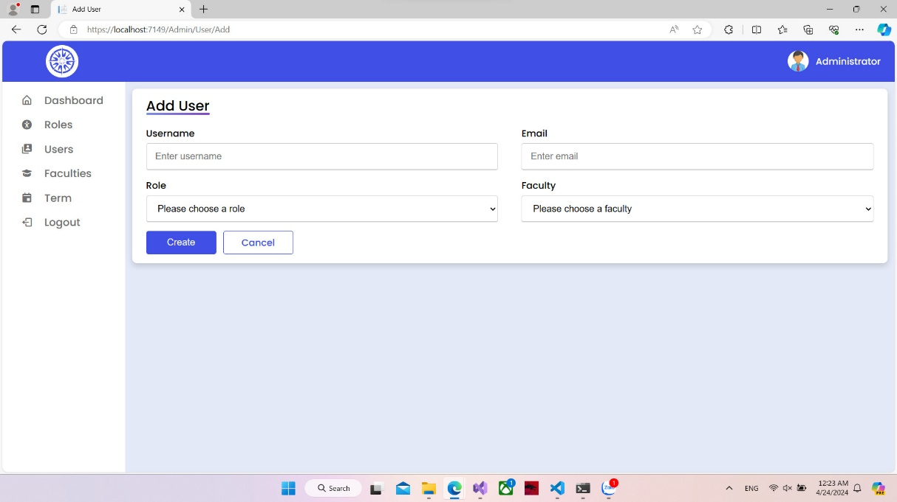

Add new user

The interface displayed provides a comprehensive view of all the data fields that an administrator is required to complete when creating a new user account. This typically includes essential information such as username, password, email address, and possibly roles or permissions. The layout is designed to be intuitive, ensuring the administrator can enter all necessary information quickly and efficiently. Clear form validation may also be in place to guarantee that the data entered meets the system's security and format standards. This thoughtful design facilitates ease of use and streamlines the user creation process, making it a hassle-free task for the administrator.

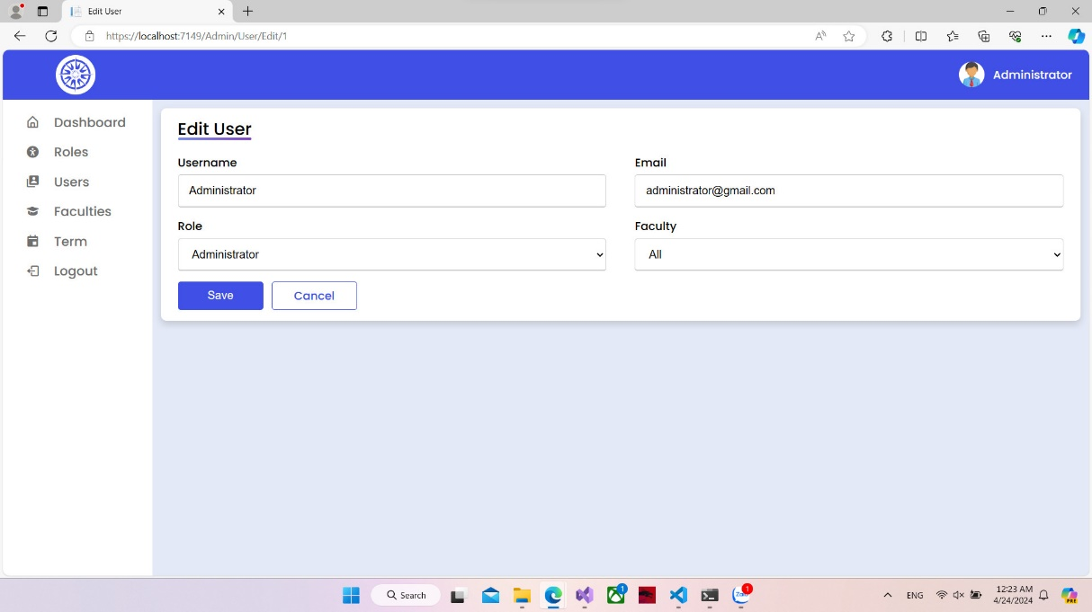

Edit user

Upon entering the edit user screen, one will encounter a view where all data fields are pre-populated with the user's existing information. This brings ease to the process of updating a user's details by allowing the administrator to quickly identify and modify only the necessary fields. The user's profile can be updated by simply altering the data in the relevant fields and then clicking the 'save' button. This process emphasizes user-friendliness and efficiency, minimizing the effort required and reducing the chances of introducing errors, ensuring that managing user information is both a convenient and accurate task for administrators.

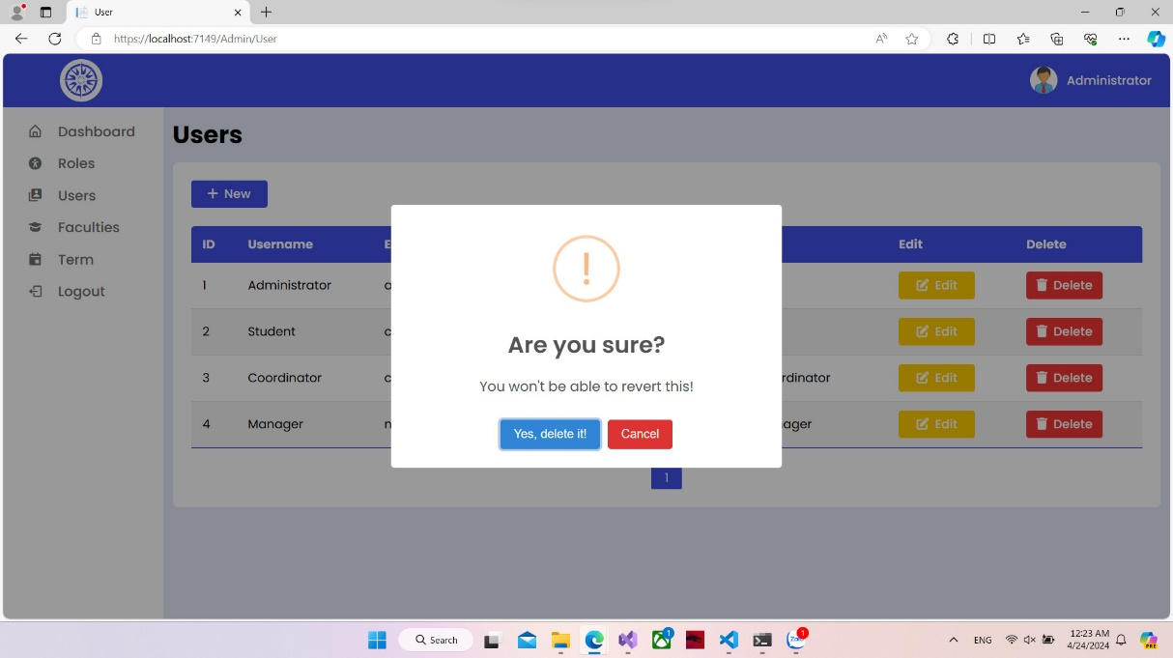

Delete user

If you find yourself in a situation where you have created an extraneous entry or an incorrect user profile, the resolution is straightforward you click the delete button associated with the specific user. Upon doing so, a notification will appear. This notification usually serves as a confirmation prompt to ensure that the decision to delete is intentional and to prevent accidental data loss. It will ask you to confirm that you indeed wish to proceed with the deletion, serving as a safeguard against unintended actions. Once you acknowledge and confirm through this prompt, the user will be removed from the system, exemplifying a simple yet effective user management control mechanism.

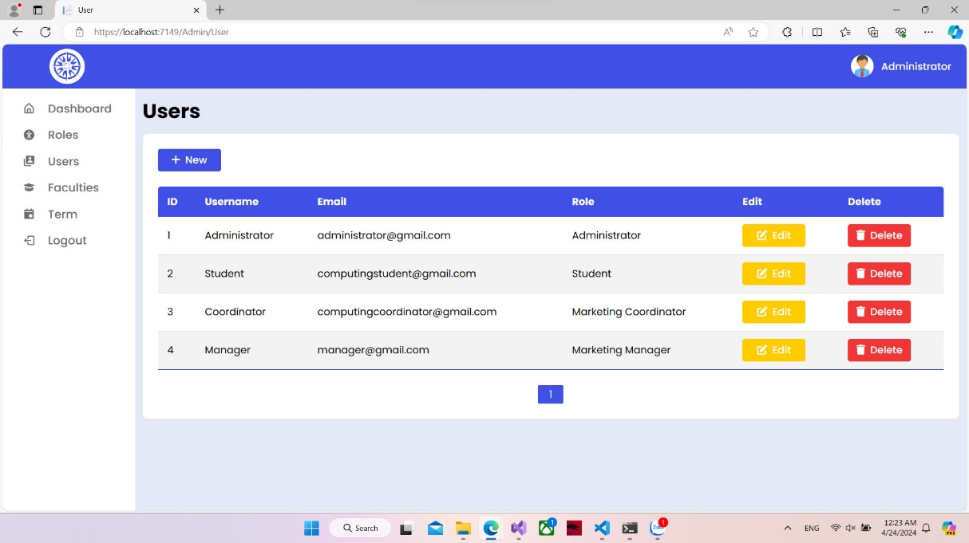

List of users

The view presents a list of users, laid out in an organized manner for easy observation and review. This might typically include columns or fields displaying usernames, email addresses, roles, and other relevant user details, enabling administrators to quickly scan and manage the user base. Such a format is especially helpful in maintaining an overview of user accounts, their status, and their access levels within a system. The design of this user list view is crafted to facilitate administrative tasks, such as editing user details, assigning roles, or removing accounts, thereby streamlining the user management process.

## Evaluation of Scrum Process

The application of the Scrum methodology by my team has been a transformative and agile process that allowed for increased productivity and clear communication. It started with our commitment to adopting an iterative approach, focusing on delivering value through small, manageable increments. In our bi-weekly sprint planning meetings, the entire team including the Product Owner, Scrum Master, and all the Developers gather around to prioritize the product backlog and set achievable goals for the upcoming sprint.

During the sprints, our daily stand-up meetings have been the linchpin of our progress. These short, time-boxed sessions provide a platform for each team member to showcase what they've accomplished, what they plan to work on next, and voice any impediments they're facing. This has not only fostered a sense of accountability but has also allowed for quick issue identification and resolution.

When it comes to execution, the Scrum roles are well-defined in our team. The Product Owner maintains and prioritizes the backlog, ensuring that the team is always working on the most valuable features. The Scrum Master acts as a facilitator and coach, safeguarding the process and removing any obstacles that may hinder the team’s performance. Meanwhile, as Backend Developers, we focus on meeting the sprint's objectives by delivering functional and reliable code.

Sprint reviews and retrospectives cap off each sprint, ensuring that we deliver a potentially shippable product increment and reflect on how we can improve. In these meetings, we openly discuss what went well, what didn’t, and how we can fine-tune our process. It is a time for introspection and collective growth.

The Scrum method’s real value for our team lies in its flexibility, transparency, and continuous learning landscape. It has shaped our work culture into one that is adaptive, collaborative, and consistently aimed at excellence. By embracing Scrum, we've achieved not just enhanced project management and productivity but also a working environment that encourages innovation and cohesive teamwork.

# Evaluation of team

## Grading

Communication and responsibility Rate

Total work (%) pie chart

Rate (10) column chart

## Evaluation

* Pham Hoang Thai played a vital role in our team as a Back-End Developer and Database Designer, showcasing exceptional skills and dedication to creating top-notch backend systems. He aligned closely with team objectives, overcoming occasional communication challenges with professionalism. Thai's input in backend coding and database design significantly influenced our project's architecture, promising scalability, and efficiency. Despite areas for improved teamwork and dialogue, Thai's expertise and commitment undoubtedly enhanced our team's dynamic and propelled our project towards its successful completion.
* Nguyen Tran Le Thanh excelled as Product Owner and System Architect, his decisive leadership and vision driving the project. He simplified complex demands into executable tasks, guiding the team with clarity. His strategic thinking ensured we met stakeholder needs and his expertise steered the project's direction. Thanh's leadership was a fundamental asset to our triumph and set a benchmark for team excellence.
* Pham Hong Son played an instrumental role in elevating the quality and reliability of our software offering. His active participation in team gatherings was highly valuable; he provided insight into effective testing strategies and protocols. Employing meticulous testing methods and demonstrating a keen eye for detail, Son was pivotal in uncovering critical issues at early stages of development. This proactive approach allowed for swift corrective actions, preemptively averting potential complications. Additionally, his ability to succinctly and articulately convey test findings greatly enhanced collaborative efforts, reinforcing a culture of responsibility and openness within the team.
* Tran Le Duy Trong was pivotal in shaping our project as a Web Designer and Front-End Developer, blending creativity with technical skill to elevate the user experience. His collaborative efforts were key, turning design concepts into compelling and user-friendly interfaces that boosted our project's functionality and visual appeal. Trong's effective communication and willingness to engage in discussions enhanced team synergy and goal alignment. Despite occasional challenges in meeting deadlines, his work in web design and front-end code significantly enriched the project's quality and user satisfaction. His innovative spirit and proficiency were invaluable to our team's success, showcasing his relentless pursuit of excellence.
* Vo Tuan Kiet was pivotal in our project as both a Back-End Developer and Database Designer. His technical acumen led to robust backend solutions vital for our goals. Kiet's problem-solving skills shone when programming and structuring our databases, ensuring system efficiency and scalability. Even with some communication hurdles, his technical contributions were fundamental to our project's architecture and success. Dedicated and always willing to exceed expectations, Kiet's work was key to our team's achievements.
* Duong Van Hiep, as Scrum Master and Front-End Developer, I dedicated myself to contributing with expertise and a deep commitment to team success. I facilitated clear communication and teamwork, aiding in navigating hurdles and fostering an adaptive team environment. Simultaneously, I used my technical abilities to craft engaging interfaces, enhancing our project's usability. Balancing both roles, I acknowledge there were times when improved communication and time management could have further improved my contributions.

# Self – evaluation

## Contribution

As a Backend Developer, one is charged with the critical task of engineering the server-side components of a software application or information system. This includes creating the infrastructure for databases, implementing algorithms, and developing various backend processes. A Backend Developer’s responsibilities may encompass data storage solutions, ensuring secure user authentication that allows the front-end portion of an application to interface with the backend efficiently. By focusing on server-side logic, security protocols, and database management, Backend Developers provide the sturdy and necessary structure that upholds the application, making it functional and responsive for the end-user. During my participation, I was assigned tasks that seemed impossible to complete with my knowledge. In my opinion, below are the functions that gave me the most difficulty:

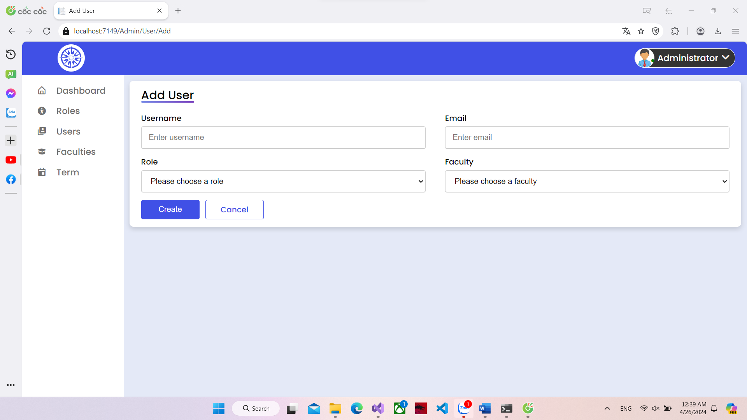

Add User Functionality

Although this function is not too difficult, it is enough to take me nearly 5 hours of work to complete it at an average level. What I faced when building this function was how to manage all possible situations when creating a new user such as: entering missing data fields, entering the wrong data type, and other problems. security topic.

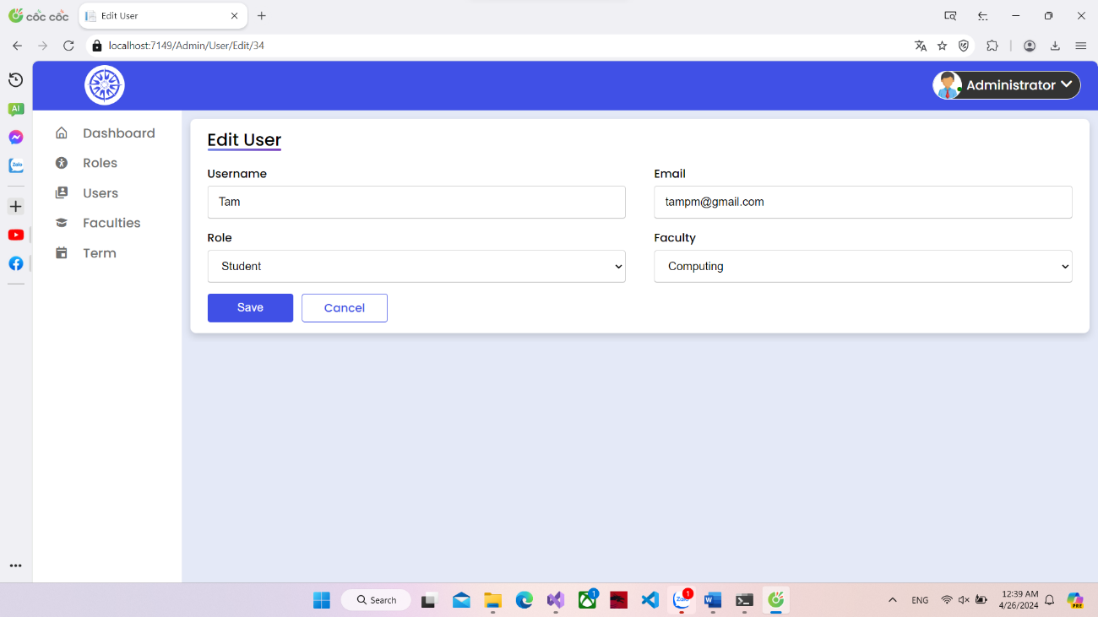

Edit User Functionality

As for the editing function, it took me more than 6 hours of work. Like the function of creating a new user, it is not too difficult but to be able to manage all possible cases.

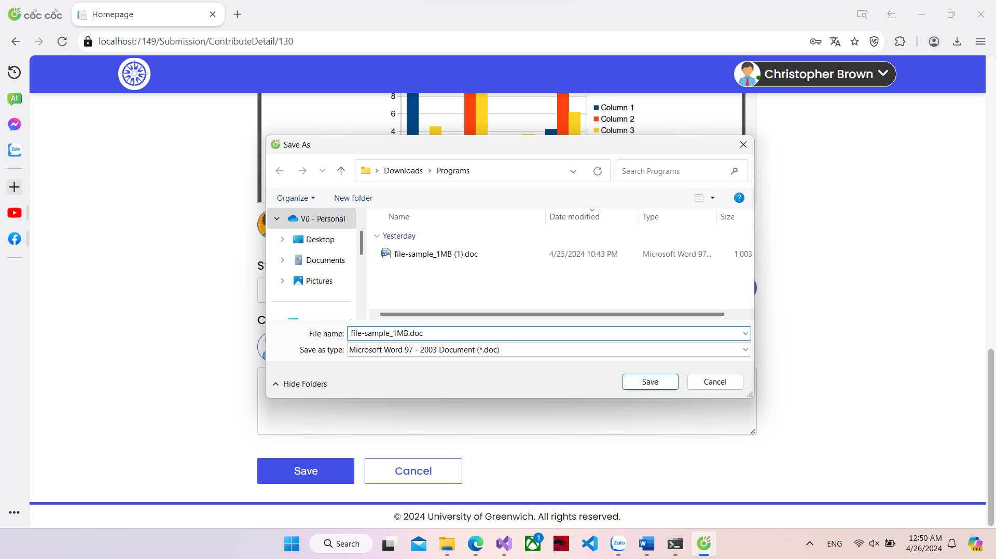

Download functionality

As for the download function. This is an extreme challenge for me. For this function to work at a low level, it took me more than 3 days to search for documents online for reference and more than 12 hours of work to create it. programming and debugging. After completing this function, I had to try many support libraries and change the code five times to get this function to work.

## Experience gained

Embarking on the role of a Backend Developer has been a journey marked by continual learning and professional growth. At its core, the role has involved tapping into a deep well of technical knowledge, from understanding complex server-side logics to mastering database management and API integrations. Each project has honed my ability to write clean, maintainable code and has sharpened my problem-solving skills. By collaborating closely with Frontend Developers and Designers, I've gained insights into the full spectrum of the development process and how the backend infrastructure supports and interacts with user-oriented aspects.

One of the key experiences gained has been the critical importance of communication within a multidisciplinary team. Expressing complex technical issues in an understandable manner, deciphering the technical needs from product managers, and translating them into functional code, requires not just programming expertise but also articulate communication. Regular stand-ups, sprint planning, and retrospective meetings have been invaluable in fostering a culture of openness and continuous improvement.

Working in a dynamic field has compelled me to remain an eternal student keeping abreast with the latest programming languages, frameworks, and best practices is part of the course. It's not just the hard skills that have developed; soft skills such as patience, understanding client needs, and team dependability have been equally vital to my role. The collaborative interfaces, data processing scripts, and security measures I've implemented stand testament to the tangible impact of my contributions.

Moreover, playing a role in creating scalable and secure backend solutions has been immensely gratifying. It's rewarding to know that the systems I build empower the Frontend to dazzle and engage users, while I ensure that everything ticks along robustly under the hood. My experience as a Backend Developer has been a unique amalgamation of creativity, logic, and collaboration each line of code not simply a set of instructions but a step towards creating something impactful.

# Material

GitHub Repository: <https://github.com/ScrumTeamCOMP1640/University-Magazine-Contribution-System>

Screen cast: <https://drive.google.com/drive/folders/1s69Ca1mX4ERCi0BhDC6XRIT1dff5W6mP?usp=drive_link>

# Conclusion

In conclusion, joining a team that employs the Scrum framework as a Backend Developer has been an enriching and growth-filled journey. The iterative nature of Scrum with its sprints and frequent reviews has granted me the opportunity to consistently refine and adapt the backend modules I develop, ensuring they serve the evolving needs of the product. It's not just about writing code; it's about being a part of a living process, where communication, collaboration, and adaptability are as imperative as technical prowess. The transparency in goals and progress Scrum advocates has helped me align my work with the entire team's efforts effectively. This experience with Scrum has immensely contributed to my professional development, enhancing my ability to build robust, secure, and efficient systems that are integral to our success.